**Instructions for Ncvm_vmc_100mtr**

**Introduction**

In Ncvm_vmc_100mtr board we can run up to 100 motors using multiplexer model. Bluetooth module is used for communication between an app and the board. To power up this board we are using 12vdc or 24vdc supply which is provided by the SMPS. We have protocols for this board to give command and to get status of the board, here an app will send protocols to perform required action.

**Required hardware & software**

1. Ncvm_vmc_100mtr board
2. Bluetooth module
3. SMPS of 12vdc or 24vdc with required 1amps
4. Motors
5. Crimp pins for connecting cables
6. Connectors for motors and power supply
7. Connector for Bluetooth module
8. NRF app from play store or app store

**Hardware setup**

1. SMPS connection - Connect SMPS output power supply to board’s input supply.
2. Bluetooth connection - Bluetooth module will have 6 pins connector from there to board’s Bluetooth port should be connected using 6pin RMC cable.
3. Motor connections – motors are connected in multiplexer model which means motors are arranged in rows and columns.

Row: Take all the pulse pins of the pulse motor in a row then connect them together and give it to the motor positive signal port of the board. (If it’s a timing motor connects all the positive pins of the timing motor).

For example: if 10 motors are in the first row then connect all the pulse pin from all 10 pulse motors together and should be connected to the first pin of the positive signal port. So that if signal is given to the first pin, then first row is selected. (If it’s a timing motor connects all the positive pins of the timing motor)

Likewise, column connection is given.

Column: Take all the ground pins of the motor in a column then connect them together and give it to the motor ground signal port of the board. (If it’s a timing motor then connects all the ground pins of the timing motor).

For example: if 10 motors are in the first column then connect all the ground pins from all 10 motors together and should be connected to the first pin of the ground signal port. So that if signal is given to the first pin, then first column is selected. (If it’s a timing motor then connects all the ground pins of the timing motor).

If the first row and first column is selected then motor-1 will be running, if first row and second column is selected then motor-2 will be running and so on.

Port p14 is the row and p15 is the columns in the board.

Rows and columns motor arrangements given below,

Wiring diagram is given below,

**Software setup**

Install NRF app from play store or from any other secure site on the smartphone which is going to be used for testing. After installing enable Bluetooth and location. Click this link to download - [nRF Connect for Mobile - Apps on Google Play](https://play.google.com/store/apps/details?id=no.nordicsemi.android.mcp)

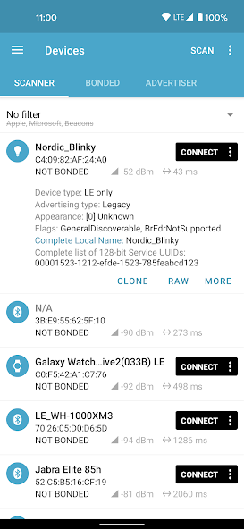

Sample image of the app.

**Protocols**

To check board is turned on or Bluetooth is connected or not, ping protocol is send.

Ping – 7B7C010204A17C7D

For Single motor,

Motor1 – 7B7C01020101 01 0100000002 A17C7D

Motor2 – 7B7C01020101 01 0200000002 A17C7D

Motor3 – 7B7C01020101 01 0300000002 A17C7D

Motor4 – 7B7C01020101 01 0400000002 A17C7D

Motor5 – 7B7C01020101 01 0500000002 A17C7D

Motor6 – 7B7C01020101 01 0600000002 A17C7D

Motor7 – 7B7C01020101 01 0700000002 A17C7D

Motor8 – 7B7C01020101 01 0800000002 A17C7D

Motor9 – 7B7C01020101 01 0900000002 A17C7D

Motor10 – 7B7C01020101 01 0A00000002 A17C7D

Motor11 – 7B7C01020101 01 0B00000002 A17C7D

Motor12 – 7B7C01020101 01 0C00000002 A17C7D

Motor13 – 7B7C01020101 01 0D00000002 A17C7D

Motor14 – 7B7C01020101 01 0E00000002 A17C7D

Motor15 – 7B7C01020101 01 0F00000002 A17C7D

Motor16 – 7B7C01020101 01 1000000002 A17C7D

Motor17 – 7B7C01020101 01 1100000002 A17C7D

Motor18 – 7B7C01020101 01 1200000002 A17C7D

Motor19 – 7B7C01020101 01 1300000002 A17C7

Motor20 – 7B7C01020101 01 1400000002 A17C7D

Motor21 – 7B7C01020101 01 1500000002 A17C7D

Motor22 – 7B7C01020101 01 1600000002 A17C7D

Motor23 – 7B7C01020101 01 1700000002 A17C7D

Motor24 – 7B7C01020101 01 1800000002 A17C7D

Motor25 – 7B7C01020101 01 1900000002 A17C7D

Motor26 – 7B7C01020101 01 1A00000002 A17C7D

.

.

.

Motor97 – 7B7C01020101 01 6100000002 A17C7D

Motor98 – 7B7C01020101 01 6200000002 A17C7D

Motor99 – 7B7C01020101 01 6300000002 A17C7D

Motor100 – 7B7C01020101 01 6400000002 A17C7D

For paired motors,

Motor1 & motor2 – 7B7C01020101 02 0102 000002 BA7C7D

Motor3 & motor4 – 7B7C01020101 02 0304 000002 BA7C7D

Motor5 & motor6 – 7B7C01020101 02 0506 000002 BA7C7D

Motor7 & motor8 – 7B7C01020101 02 0708 000002 BA7C7D

.

.

.

Motor99 & motor100 – 7B7C01020101 02 6364 000002 BA7C7D

**Working**

Turn on the board so that Bluetooth name will be visible on the nrf app. If it's not visible click on scan button. Then name will be listed below.

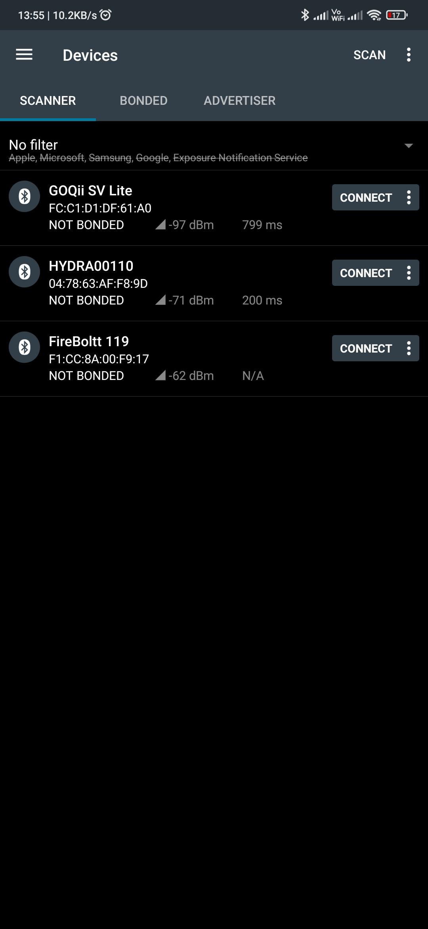

Click on the connect button to make connection between smartphone and the board. You can verify the connection status in blue letters.

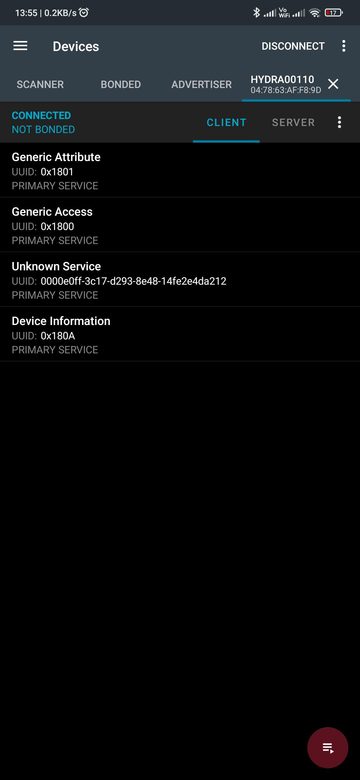

Click on unknown service.

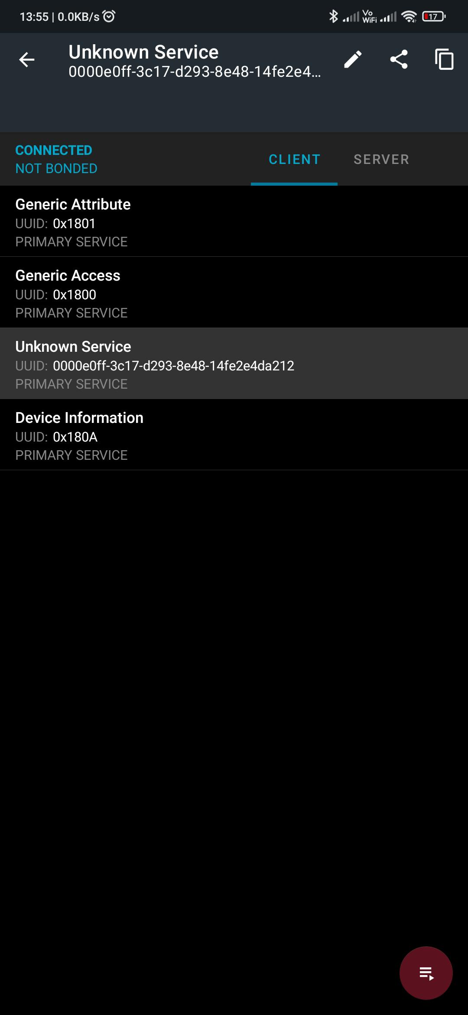

List down the write and read option.

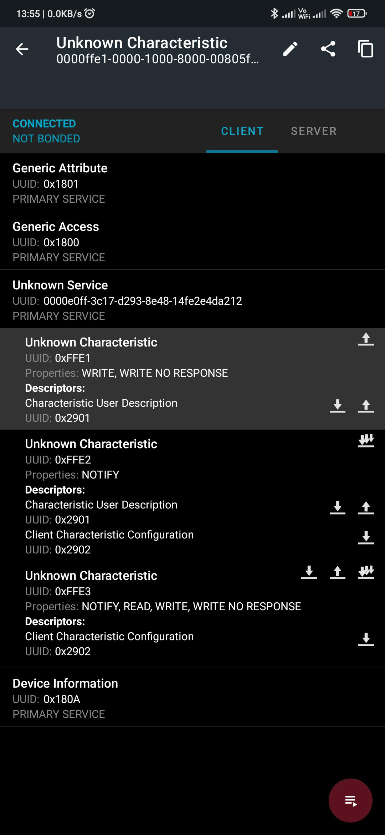

Click on the 3 down arrow to enable notify, after clicking on it will icon will get crossed.



Click on the upward arrow to send data which is available in the unknown characteristic

Enter the protocol data and click on sent for the board, if you want it to be saved for future use you can also click on save.

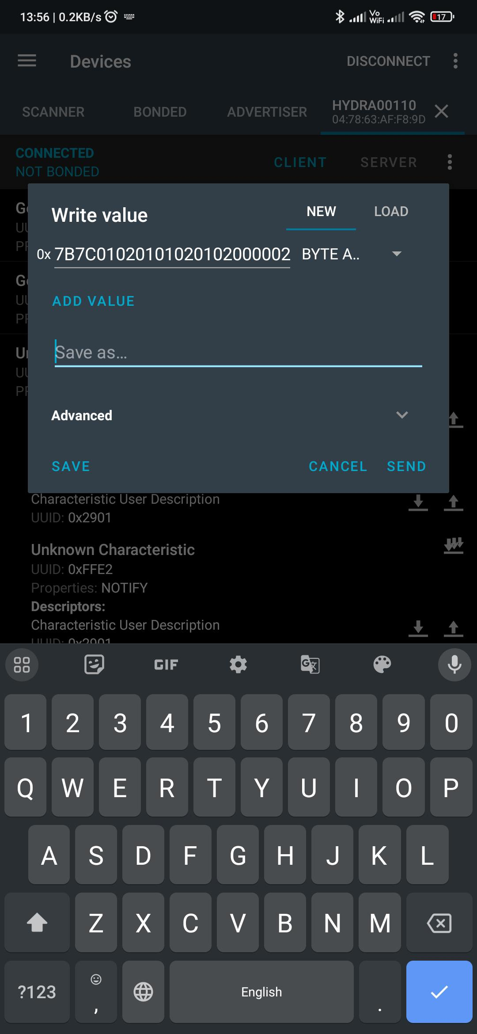

If you slide the screen to the right, then you can be able to see the response from the board.

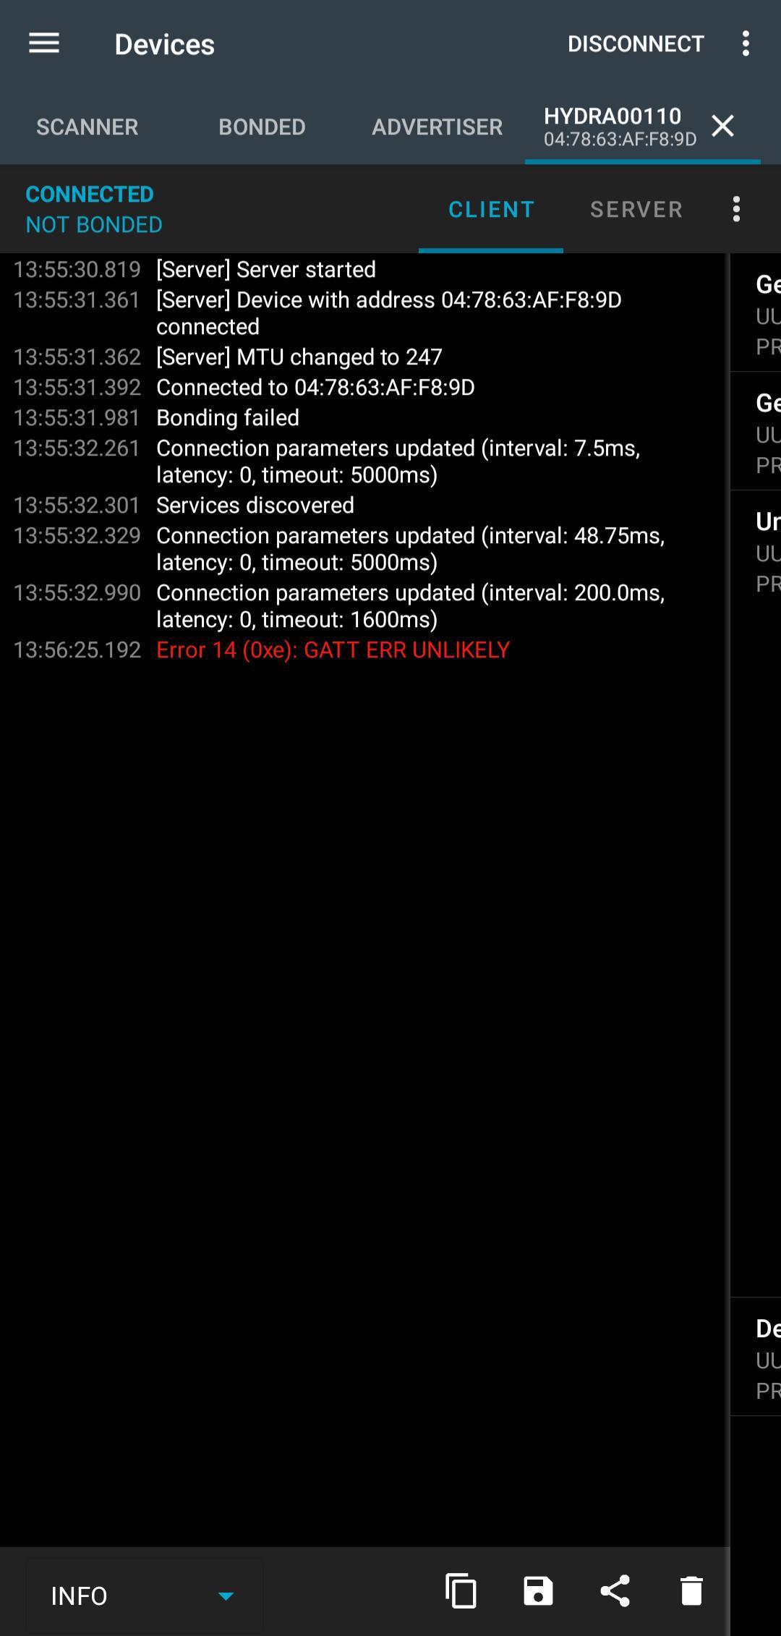

Using these steps, we can send instruction to the board and get responses from the board.